Nirma Universlty

Institute of Technology

#### Semester End Examination (IR), May - 2019

B Tech. in Computer Engineering / Information Technology, Semester-VI

1T60 1 Software Engineering

Roll / Exam No.

## Time: 3 Hours

### Instructions: 1. Attempt all questions.

Supervisor’s initial with date

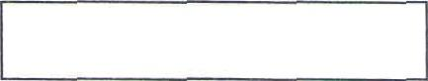

flax. Narks : 100

### Figures to right indicate full marks.

1. Use section-wise separate answer book.

### Draw neat sketches wherever necessary.

1. Attempt questions in sequence only.

## Section - I

### Q-1. Do as directed:

1. You have been appointed as a project manager within a software CO IBL4 company. Your job is to build an application that is quite similar to others your team has built in the past, although this new one to be

#### built is larger and more complex system compared to the ones your team developed in past. Requirement have been documented thoroughly for the new system to be developed. Which process model would you choose and why*

1. “Both the waterfall model of the software process and the prototyping CO1BL3 model can be accommodated in the spiral process model.” Justify

with appropriate example.

1. Giving reasons for your answer based or the type of system being CO1BL4 developed, suggest the most appropriate generic software process model that might be used as a basis for managing the development

of the following systems:

### A system to control anti-lock braking in a car

#### A virtual reality system to support software maintenance

* 1. A university accounting system that replaces an existing system
  2. An interactive system that allows railway passengers to find

#### train times from terminals installed in stations.

Q-2. Do as directed:

A Read the following description. “Customers of the garage can buy CO2BL3 cars. Customers with a bad credit should pay an extra down payment". Determine which of the following diagrams represent this

description and justify the same. Refer the diagrams in next page:

### [16]

[04]

### |04] [08j

#### (18] lO2]

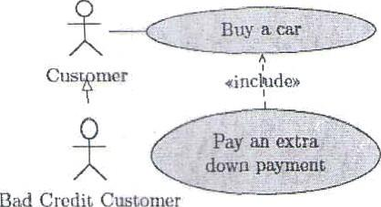 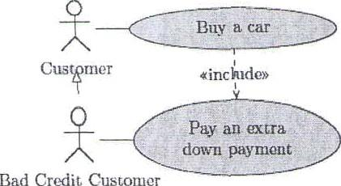

1. b)

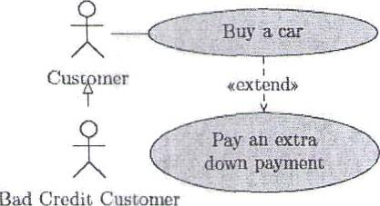 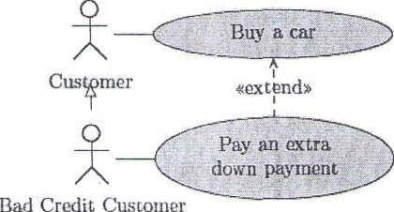



# CO2BL3

C

# CO2BL1

D

##### CO2BL4

c) d)

“It is important to make a distinction between developing the user requirements and developing system requirements in the requirements engineering process.” Justify with appropriate example.

Differentiate between milestones and deliverables. Also, prepare a set of task list stating dependencies, milestones and deliverables for a project for developing Library Management System for Nirma University.

Create a state diagram for ATM Machine w.r. t following functionality: An ATM Machine at first is in OFF Mode. When switch is turned on and startup is performed, machine is idle, will ask the user to insert ATM Card. After reading the card, if card is accepted, the machine asks for pin number. If card is not accepted or is not readable, the card will be ejected. If pin number is authenticated, the user will be prompted with transactions to choose. If user enters wrong pin number, the machine asks for pin number again. If invalid pin number is entered more than 3 times, the card will be retained by the machine. The transaction chosen by the user will be performed and corresponding receipt will be printed. Later, card is ejected from the machine. The user can opt for taking several executions for choosing a transaction he/ she wants to perform. At any point of time, if user presses on ‘Cancel”, the card will be ejected. The machine will be go from idle to OFF Mode, when switch is turned off and shutdown is performed.

104)

[06{

[06]

OR

Consider the following simplified description of a university where professors teach courses in which students can enroll. A professors has a name, address, phone number, email address, and salary. A student has also a name, etc., but no salary (sorry). A student, however, has an average mark (of the final marks of his or her courses). A course has a name and a number. When a student is enrolled in a course, the marks for this enrollment are recorded. From enrollment, the current average as well as the final mark (if there is one) can be obtained. From a student, one can obtain a list of courses he or she is enrolled in. Professors can teach many courses. Each course has at least one and at most three teachers. A student can get enrolled in exactly 5 courses. A course can be offered

[06]

only if at least one student is enrolled in it. There are two types of course: bachelor and master. From a bachelor course students can not withdraw. From a master course they can.

Design a class diagram for this university. Add attributes and methods when necessary. Make use of the concepts of object oriented programming.

**Q-3. Do as directed: [16]**

1. Explain why the process of project planning is iterative and why a [04] CO4BL2 plan must be continually reviewed during a software project.
2. Describe different types of risks and gives examples for each. For [06]

CO4BL2 Attendance Management System, identify the risks involved, their types, along with its probability and effects.

OR

1. Discuss the various phases of CMMI model. What is the difference {06] CO4BL2 between generic and specific goals in CMMI?

C A project consists of 8 activities named A to H. Consider the following [06] CO4BL4 table:

| Activity | Completion time lin days) | | Immediate predecessor  activities |
| --- | --- | --- | --- |
| A | *5* | |  |
| B | 7 | |  |
| C | 6 | |  |
| D | 3 | | A |
| E | 4 | | B, C |
| F 2 | | | C |
| G | 6 | | A, D |
| H | | 5 | E, F |

* 1. Construct activity network so as to satisfy the scheduling requirements shown in the table.
  2. Find the least time required to complete the whole project.
  3. Identify the critical path.
  4. How is the project completion time affected if:
     1. activity E is delayed by 3 days
     2. activity F is delayed by 3 days

**Section** - II

##### Q-4. Do as directed: [1ti]

justify with respect to good software design, what should be the |O4]

**CO3BL3** B **CO3BL3**

“right” number of modules? Also, show with help of diagram.

Apply bottom up integration testing and show the levels of [04] integration test to be performed on the followin example.

M t1

M9

M8 M4 MS

Mt W2

c Justify why design conflicts might arise when designing an [04]

**CO3BL3** architecture where performance and maintainability requirements are the most important functional requirements.



| D  **CO3BL4**  **Q-5.** | ln an Examination, a candidate has to score a minimum of 24 marks in order to clear the exam. The maximum that he can score is 40 marks. Categorize the mentioned definition into equivalence classes and also infer the boundary values.  **Do as directed:** | [04]  **[16]** |
| --- | --- | --- |
| A | Differentiate between reverse engineering and forward engineering. | [04s |
| CO5BL2  B | Also, illustrate the process of reverse engineering  Interpret the relation between internal and external software | [06] |
| COSBL1 | attributes for quality management. Explain static software product metrics for quality management.  OR |  |
| B | Explain how baseline SCls are established in software configuration | {06] |

**COSBL**1 management. Also, explain SCM features in detail.

C Describe risk assessment in the field of security engineering.

##### CO5BL1

OR

1. Describe mentioned agile process models in detail:

**COSBL**1 a) Adaptive Software Development tASD)

1. Extreme Programming (XP)
2. Dynamic Systems Development Method (DSDM}.

##### Q-6. Do as directed:

A A company needs to develop a strategy for software product **CO3BL3** development for which it has a choice of two programming languages L1 and L2. The number of lines of code (LOC) developed using L2 is

estimated to be twice the LOC developed with L1. The product will have to be maintained for five years. Various parameters for the com an are iven in the table below.

[06]

## }06}

[18]

|06]

Parameter Lan a e L1 Man years needed LOC/ 10000 for develo ment

Development cost Rs. 10,00,000 er man ear

Maintenance time 5 ears

Cost of maintenance Rs. 1,00,000

#### Lan a e L2

LOC/ 10000

Rs. 7,50,000

5 ears

## Rs.50,OOO

per year Total cost of the project includes cost of development and maintenance. Evaluate LOC for L I and LOC for L2 for which the cost

of the project using L1 is equal to the cosr of the project using L2?



**CO3BL4**

Consider the following function: insertion_procedure (int a| ], int p [ ], int N)

int i, j, k;

for (i=0; i<=N; i++) for (i=2; i<=N; i++)

k = p[i]; j — 1 ,

while (a[p|j- 1]] > a[k])

|O6]



 

printf("Value of p[%d] is %d", j, pd ]);

Perform the following:

1. Design the control flow graph for the given code.

#### Determine cyclomatic complexity and generate independent

paths using basis path testing.

C Country Bank plans to create its on-line banking application. The coaBL3 application interface allows customers to check balances, transfer

funds and bill payment services.

To enter the on-line banking application, the uset enters a preassigned user name and a password.

Once validated, the user gains access to a main menu which

displays the following links:

* Check balances
* Transfer funds
* Bill Payment

The user will be able to check his balance by inquiring his/ her account. Transferring funds will require the ii ser to enter name, account number, IFSC code, amount to be transferred and a transaction pin.

Payee data will be maintained by the on-line banking application in a

Payee logical file through add payee and make changes to payee transactions. Display payee will retrieve data from the Payee logical file and will not include any calculations. Payment by Country Bank check will be generated and mailed to a designated payee when Make payment has been selected and submitted, the payment date will be recorded into the Payee logical file when the check is created as an output. The functionality shown below is being added via the Bill Payment screen.

* Add a payee
* Display payee
* Make changes to a payee
* Make a payment : Generate check

All of these data are of average complexity and overall system is moderately complex i.e. assume sum of value adjustment factors is TO. Given the historical data that the organizational average productivity for systems of this type is 9.5 FP/pm. Also, labor rate is of Rs 32,000 per month. Based on the data provided, compute the following:

1. Compute FP for the system.
2. Measure the total estimated project cost of the system. Weighting factors required are provided as follows:

| Simple | Average | Complex |
| --- | --- | --- |
|  |  |  |
|  | 5 | 7 |
| 3 |  | 6 |
| 7 | 10 | 15 |
|  | 7 | 10 |

Page 5 of 5

[06]